**Final Project Proposal: Matt Catalano, Yasmin Lorin Kaygalak, Abdullah Al Rafi Mahmud**

● 11/14 at 11:59 PM: Project Proposal outlining the conceptual idea of the application you will be developing. This proposal should include the following:

○ A brief project summary (i.e what does your application do?)

○ A tentative business rules and restrictions that your database might have.

○ A tentative ER diagram showing the conceptual model for the DB

○ A schema representation for the ER diagram.

Ride Sharing Service

Different Tables:

1. Person – name, id, address, phone number, email
2. Trip information- destination, departure time, number of riders, car, trip ID, person id
3. Car- make/manufacturer, model, year manufactured, number of seats, license plate number (unique ID), owner, TH id (foreign key)
4. Trip history – ID, destination, number of riders, departure time

**Project Summary**

Our application is similar to Uber, but is more tailored to college campuses, specifically Villanova, aiming to help students save through initiating shared trips. The general idea is that there are many people on campus who do not have cars, and also many people with cars who drive places without every seat in their car filled. Our application will create a database where users will enter trips they intend to make (i.e. to the Wells Fargo Center), and then other users can join in on the trip. Users will be able to see the destination of a trip, the type of car that the driver is driving, and will not be able to schedule two trips that have overlapping times. The idea is that through this application, students will save a significant amount of money, and they will ideally share the gasoline cost of the trip. Furthermore, the application will allow students to group and share an Uber/Lyft together to go to their destination, in the scenario of none of the students having a car. Through this, students will get to split the cost of the ride, save a significant amount of money, and pollute the environment less by gathering in one car - rather than multiple cars going to the same destination at the same time.

**Tentative Business Rules and Restrictions**

1. Every trip must have at least one rider.
2. Every car can at most have 4 passengers.
3. The arrival time must be later than the departure time.
4. A person cannot be on/schedule for two trips that have overlapping times.
5. A person who is designated as a driver must own a car.
6. Every shared trip through Uber/Lyft can have at most 4 people.

**ER Diagram**

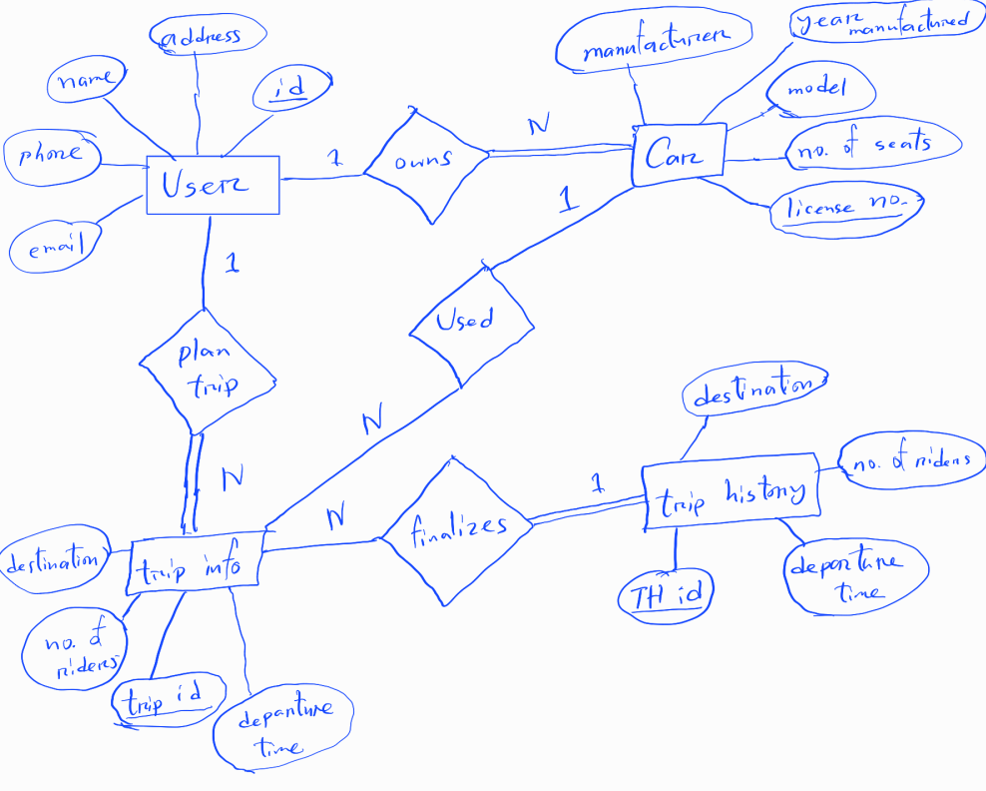

**Schema Representation for the ER Diagram**

